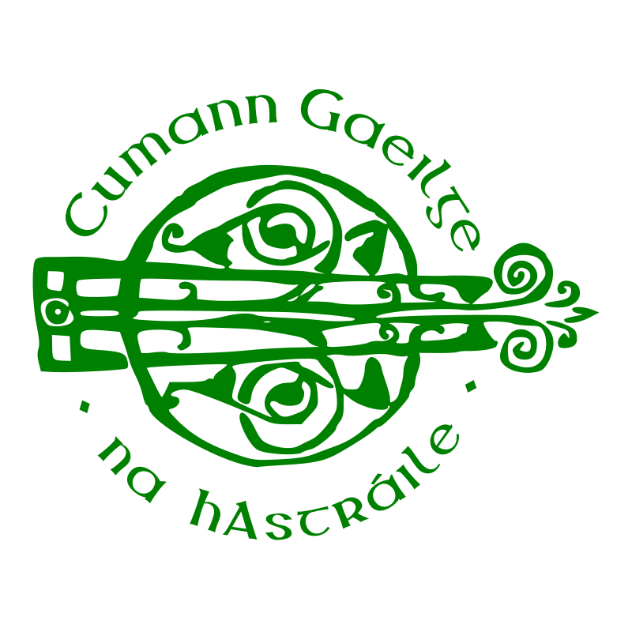

The Barney Devlin Memorial Irish Language Scholarship
Barney Devlin was a well-known scholar of the Irish Language in Australia. Barney was known to many in the Irish Community as a teacher and student of Irish, a playright, a mentor and a friend.
Born in Belfast in 1944, he died in Canberra in June 2018, after a short illness. To honour his memory his family created two scholarships in his name, the first of which was awarded at Gaeltacht Melbourne in January 2020.
The second scholarship is now on offer, to be awarded to a dedicated student of the Irish language, who has demonstrated ongoing commitments to furthering the language.
Students wishing to be considered for a $200 scholarship in January 2022 should complete the application below and return it to:
amdevlin44@gmail.com
by Friday 14 January 2022.

Application
- Please tell us your story of learning Irish. Include all programs, classes, study, voluntary work, reading, travel and any other efforts you have made to learn and improve your Irish.
- Please tell us how the $200 would help you in meeting costs associated with learning the Irish language.

